***TASK # 1***

***HOME:***

*<!DOCTYPE html>*

*<html lang="en">*

*<head>*

*<meta charset="UTF-8">*

*<meta http-equiv="X-UA-Compatible" content="IE=edge">*

*<meta name="viewport" content="width=device-width, initial-scale=1.0">*

*<title>Document</title>*

*<link rel="stylesheet" href="style.css">*

*</head>*

*<body>*

*<div>*

*<H1>HOME</H1>*

*<ul>*

*<li><a href="Home.html">Home</a></li>*

*<li><a href="infomation.html">Information</a> </li>*

*<li><a href="gallery.html">Gallery</a></li>*

*<li><a href="about us.html">About Us</a></li>*

*</ul>*

*</div>*

*<CENTER>*

*<div>*

*<img src="IMAGES/pic 3.jpg " >*

*</div>*

*<div>*

*<h1>Introduction of photopraghy</h1>*

*<P>Photography is a way of making a picture using a camera.*

*A person who makes pictures using a camera is called a photographer.*

*A picture made using a camera is called a photograph or photo.*

*Photography became popular in the middle 19th century with Daguerreotype.*

*Is the art of capturing light with a camera, usually via a digital sensor or film, to create an image.*

*With the right camera equipment, you can even photograph wavelengths of light invisible to the human eye,*

*including UV, infrared, and radio.</P>*

*</div>*

*</CENTER>*

*</body>*

*</html>*

***OUTPUT:***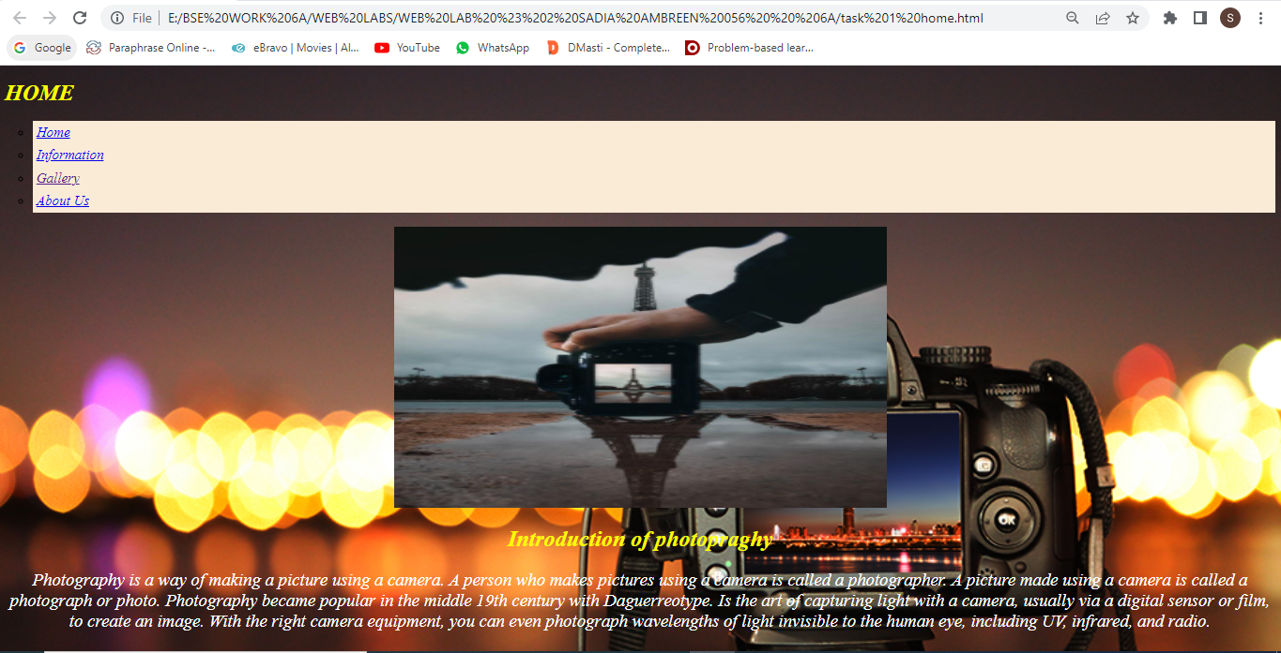

***INFORMATION:***

*<!DOCTYPE html>*

*<html lang="en">*

*<head>*

*<meta charset="UTF-8">*

*<meta http-equiv="X-UA-Compatible" content="IE=edge">*

*<meta name="viewport" content="width=device-width, initial-scale=1.0">*

*<title>Document</title>*

*<link rel="stylesheet" href="style.css">*

*</head>*

*<body>*

*<div><h1>INFOMATION</h1>*

*<ul>*

*<li><a href="Home.html">Home</a></li>*

*<li><a href="infomation.html">Information</a> </li>*

*<li><a href="gallery.html">Gallery</a></li>*

*<li><a href="about us.html">About Us</a></li>*

*</ul>*

*</div>*

*<div>*

*<h1>PRINCIPLE OF PHOTOGRAPHY</h1>*

*<P>*

*The seven principles of art and design in photography; balance, rhythm, pattern, emphasis,*

*contrast, unity and movement, form the foundation of visual arts. Using the seven principles*

*allows you to take greater control of your photographic practice.*

*This will lead to better photos and more photographic opportunities.*

*</P>*

*<h1>USES OF PHOTOGRAPHY</h1>*

*<p>Photographs are used to tell stories in many different ways.*

*Sciences use photography to document new plants or to be able to study animals in more depth.*

*Photos are used in text books to teach students about different places around the world.*

*Family portraits hang on walls of almost every home.</p>*

*</div>*

*</body>*

*</html>*

***OUTPUT:*** 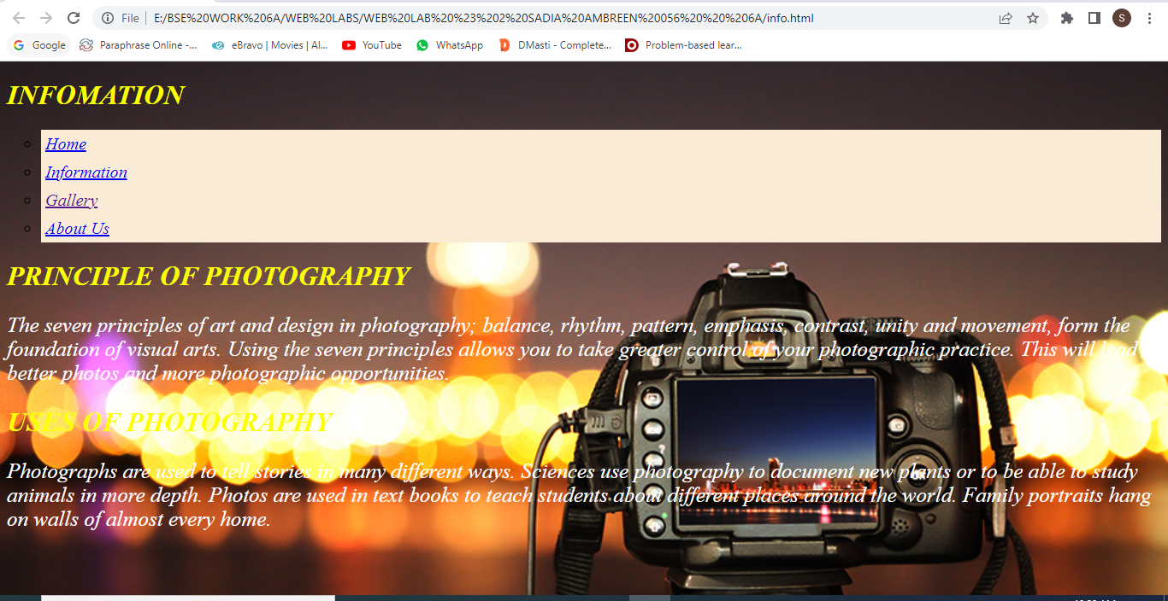

***GALLERY*:** *<!DOCTYPE html>*

*<html lang="en">*

*<head>*

*<meta charset="UTF-8">*

*<meta http-equiv="X-UA-Compatible" content="IE=edge">*

*<meta name="viewport" content="width=device-width, initial-scale=1.0">*

*<title>Document</title>*

*<link rel="stylesheet" href="style 1.css">*

*</head>*

*<body>*

*<div>*

*<ul>*

*<li><a href="Home.html">Home</a></li>*

*<li><a href="infomation.html">Information</a> </li>*

*<li><a href="gallery.html">Gallery</a></li>*

*<li><a href="about us.html">About Us</a></li>*

*</ul>*

*</div>*

*<h1>IMAGES OF PHOTOGRAPHY</h1>*

*<div class="container">*

*<div> <center> <h1>NATURE</h1>*

*<img src="IMAGES/pic 2.webp"width="500" height="500">*

*<img src="IMAGES/pic 3.jpg"width="400" height="500">*

*<img src="IMAGES/pic 4.jpg"width="500" height="600">*

*<img src="IMAGES/pic 5.png"width="700" height="500">*

*</center>*

*</div>*

*</body>*

*</html>*

***OUTPUT:*** 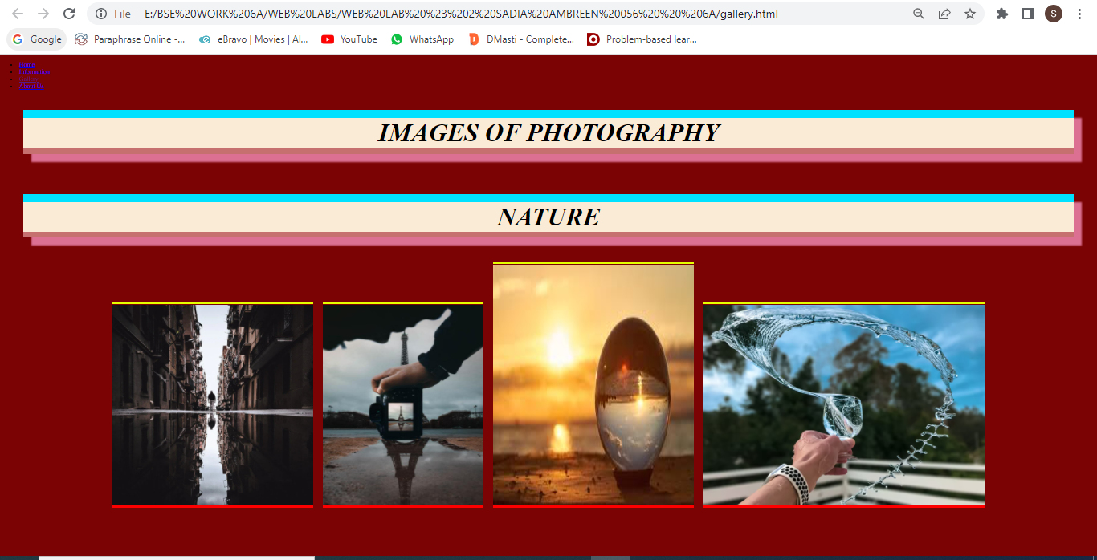

***ABOUT:***

*<!DOCTYPE html>*

*<html lang="en">*

*<head>*

*<meta charset="UTF-8">*

*<meta http-equiv="X-UA-Compatible" content="IE=edge">*

*<meta name="viewport" content="width=device-width, initial-scale=1.0">*

*<title>Document</title>*

*<link rel="stylesheet" href="style.css">*

*</head>*

*<body>*

*<div><h1>ABOUT</h1>*

*<ul>*

*<li><a href="Home.html">Home</a></li>*

*<li><a href="infomation.html">Information</a> </li>*

*<li><a href="gallery.html">Gallery</a></li>*

*<li><a href="about us.html">About Us</a></li>*

*</ul>*

*</div>*

*<CENTER>*

*<div>*

*<img src="IMAGES/pic 3.jpg">*

*</div>*

*<div>*

*<h1>ABOUT PHOTOGRAPHY</h1>*

*<h2>*

*<P>Photographs are used to tell stories in many different ways.*

*Sciences use photography to document new plants or to be able to study animals in more depth.*

*Photos are used in text books to teach students about different places around the world.*

*Family portraits hang on walls of almost every home.*

*The seven principles of art and design in photography; balance, rhythm, pattern, emphasis,*

*contrast, unity and movement, form the foundation of visual arts. Using the seven principles*

*allows you to take greater control of your photographic practice.*

*This will lead to better photos and more photographic opportunities.*

*</P>*

*</h2>*

*</div>*

*</CENTER>*

*</body>*

*</html>*

***OUTPUT:***

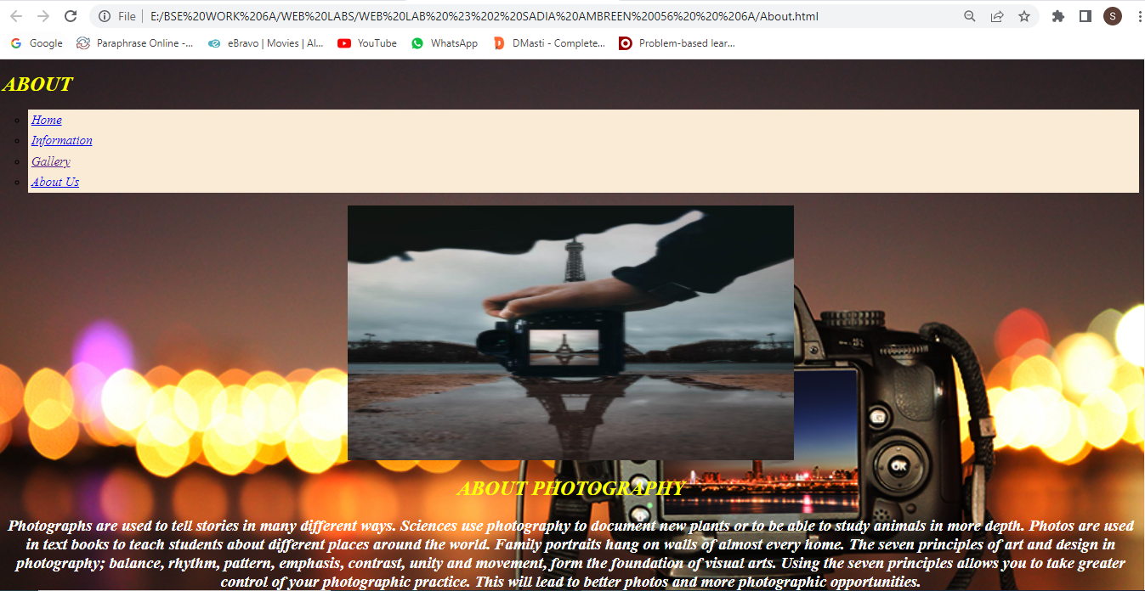

***style.css***

*ul {*

*font-style: italic;*

*font-family: 'Times New Roman', Times, serif;*

*list-style-type: circle;*

*font-size: 20px;*

*}*

*li a {*

*display: block;*

*padding: 5px;*

*background-color: antiquewhite;*

*}*

*h1{*

*font-family: 'Times New Roman', Times, serif;*

*font-style: italic;*

*color: rgb(251, 255, 0);*

*}*

*p{*

*font-size: 25px;*

*font-family: 'Times New Roman', Times, serif;*

*font-style: italic;*

*color:rgb(255, 255, 255)*

*}*

*h2{*

*color: rgb(251, 255, 0);*

*}*

*img{*

*width: 700px;*

*height: 400px;*

*}*

*body{*

*background-image: url(IMAGES/photopraghy.jpg);*

*background-attachment: fixed;*

*background-size: cover;*

*}*

***style 1.css***

*body{*

*background-color:rgb(124, 3, 3);*

*}*

*.container{*

*display: flex;*

*flex-wrap: wrap;*

*flex-direction: column;*

*justify-content: center;*

*}*

*img{*

*width: 50;*

*height: 50;*

*margin: 10px;*

*border-bottom: 7px solid red;*

*border-top: 7px solid rgb(229, 255, 0);*

*text-shadow: navajowhite;*

*transition:alt 1s;*

*}*

*img:hover{*

*transform: scale(1.1);*

*}*

*h1{*

*font-family: 'Times New Roman', Times, serif;*

*font-size: 4em;*

*border-bottom: 15px solid rgb(199, 112, 112);*

*border-top: 20px solid rgb(0, 225, 255);*

*box-shadow:20px 20px 4px palevioletred;*

*margin-top: auto;*

*margin-bottom: auto;*

*text-align: center;*

*margin: 50px;*

*background-color: antiquewhite;*

*font-style: italic;*

*}*

***TASK # 2:***

*<!DOCTYPE html>*

*<html lang="en">*

*<head>*

*<meta charset="UTF-8">*

*<meta http-equiv="X-UA-Compatible" content="IE=edge">*

*<meta name="viewport" content="width=device-width, initial-scale=1.0">*

*<title>task 2</title>*

*<style>*

*img{*

*width: 260px;*

*height: auto;*

*}*

*span{*

*font-size: 1.5em;*

*color: red;*

*}*

*.p{*

*margin: 30px;*

*font-size: 30px;*

*}*

*</style>*

*<body><CENTER>*

*<div>*

*<h1>WEB ENGINEERING</h1>*

*<img src="IMAGES/web img.png">*

*</div>*

*<div class="p">*

*<p><span>Web Engineering</span> is multidisciplinary and encompasses contributions from diverse areas:*

*systems analysis and design, software engineering, hypermedia/hypertext engineering,*

*requirements engineering, human-computer interaction, user interface, information engineering,*

*information indexing and retrieval, testing,*

*</p>*

*</div>*

*</CENTER>*

*</body>*

*</html>*

***OUTPUT:*** 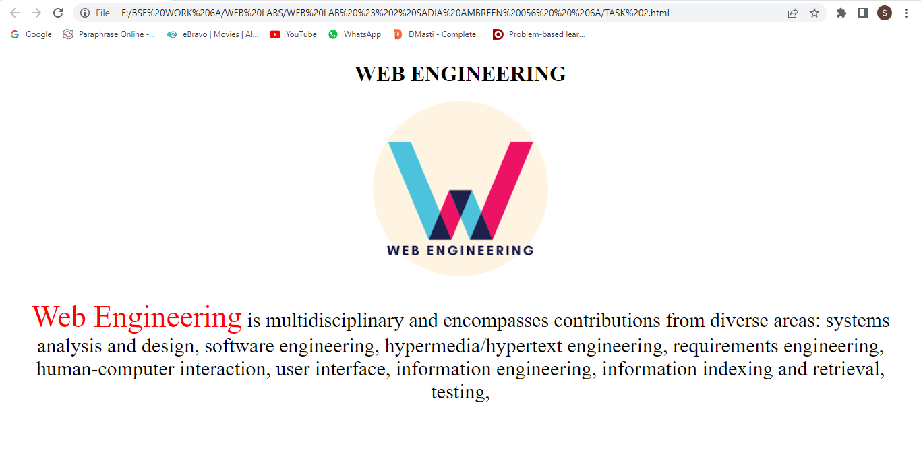

***TASK # 3:***

<!DOCTYPE html>

<html lang="en">

<head>

    <meta charset="UTF-8">

    <meta http-equiv="X-UA-Compatible" content="IE=edge">

    <meta name="viewport" content="width=device-width, initial-scale=1.0">

    <title>Document</title>

    <style>

        * {

            margin: 0;

            padding: 0;

        }

        .container{

            background-image: url('./IMAGES/photo-1516617442634-75371039cb3a.jpg');

            background-attachment: fixed;

            background-repeat: no-repeat;

            background-size: cover;

            text-align: justify;

            color: white;

            font-family: 'Lucida Sans', 'Lucida Sans Regular', 'Lucida Grande', 'Lucida Sans Unicode', Geneva, Verdana, sans-serif;

        }

        .container h1 {

            text-align: center;

            padding: 20px;

            font-size: 70px;

            font-weight: unset;

        }

        p{

            font-size: 18px;

            padding: 20px;

        }

    </style>

</head>

<body>

     <div class="container">

        <h1>TOP SCREEN OF WEBSITE</h1>

        <p>Lorem, ipsum dolor sit amet consectetur adipisicing elit. Porro nisi id aspernatur repellendus vitae quis dolorem officia ipsam eligendi sit, quos aliquid asperiores? Possimus fuga ratione harum corrupti aspernatur quae vitae voluptate, inventore sequi consequuntur. Possimus veniam repellendus aliquam enim corporis dicta consectetur, et totam sequi quaerat quasi deleniti id!</p>

        <p>Lorem ipsum dolor sit amet consectetur adipisicing elit. Aspernatur mollitia molestiae laudantium quos necessitatibus. Accusamus cum possimus ducimus quod accusantium odio quae eum necessitatibus deleniti labore at reprehenderit iure quisquam a placeat neque harum quaerat, omnis ab commodi sit amet fugiat natus nulla. Qui praesentium ducimus distinctio quam vero porro totam cupiditate repellendus iure odit, sit deleniti dignissimos corrupti autem nisi, laborum ipsa quas facere cum rem inventore, architecto incidunt in velit! Similique nisi quia ipsum optio error illo temporibus. Aperiam, blanditiis possimus assumenda maxime officia, ut voluptates iste exercitationem nulla quo vitae nemo pariatur rem officiis minima delectus eius!</p>

        <p>Lorem, ipsum dolor sit amet consectetur adipisicing elit. Porro nisi id aspernatur repellendus vitae quis dolorem officia ipsam eligendi sit, quos aliquid asperiores? Possimus fuga ratione harum corrupti aspernatur quae vitae voluptate, inventore sequi consequuntur. Possimus veniam repellendus aliquam enim corporis dicta consectetur, et totam sequi quaerat quasi deleniti id!</p>

        <p>Lorem ipsum dolor sit amet consectetur adipisicing elit. Aspernatur mollitia molestiae laudantium quos necessitatibus. Accusamus cum possimus ducimus quod accusantium odio quae eum necessitatibus deleniti labore at reprehenderit iure quisquam a placeat neque harum quaerat, omnis ab commodi sit amet fugiat natus nulla. Qui praesentium ducimus distinctio quam vero porro totam cupiditate repellendus iure odit, sit deleniti dignissimos corrupti autem nisi, laborum ipsa quas facere cum rem inventore, architecto incidunt in velit! Similique nisi quia ipsum optio error illo temporibus. Aperiam, blanditiis possimus assumenda maxime officia, ut voluptates iste exercitationem nulla quo vitae nemo pariatur rem officiis minima delectus eius!</p>

        <p>Lorem, ipsum dolor sit amet consectetur adipisicing elit. Porro nisi id aspernatur repellendus vitae quis dolorem officia ipsam eligendi sit, quos aliquid asperiores? Possimus fuga ratione harum corrupti aspernatur quae vitae voluptate, inventore sequi consequuntur. Possimus veniam repellendus aliquam enim corporis dicta consectetur, et totam sequi quaerat quasi deleniti id!</p>

        <p>Lorem ipsum dolor sit amet consectetur adipisicing elit. Aspernatur mollitia molestiae laudantium quos necessitatibus. Accusamus cum possimus ducimus quod accusantium odio quae eum necessitatibus deleniti labore at reprehenderit iure quisquam a placeat neque harum quaerat, omnis ab commodi sit amet fugiat natus nulla. Qui praesentium ducimus distinctio quam vero porro totam cupiditate repellendus iure odit, sit deleniti dignissimos corrupti autem nisi, laborum ipsa quas facere cum rem inventore, architecto incidunt in velit! Similique nisi quia ipsum optio error illo temporibus. Aperiam, blanditiis possimus assumenda maxime officia, ut voluptates iste exercitationem nulla quo vitae nemo pariatur rem officiis minima delectus eius!</p>

architecto incidunt in velit! Similique nisi quia ipsum optio error illo temporibus. Aperiam, blanditiis possimus assumenda maxime officia, ut voluptates iste exercitationem nulla quo vitae nemo pariatur rem officiis minima delectus eius!</p>

    </div>

</body>

</html>

***OUTPUT:***

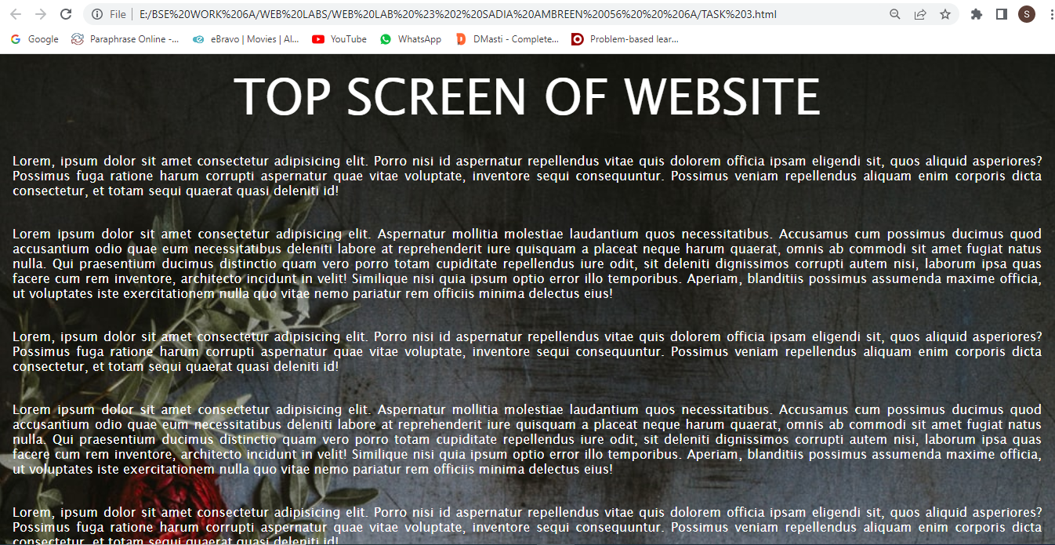

***TASK # 4***

*<!DOCTYPE html>*

*<html lang="en">*

*<head>*

*<meta charset="UTF-8">*

*<meta http-equiv="X-UA-Compatible" content="IE=edge">*

*<meta name="viewport" content="width=device-width, initial-scale=1.0">*

*<title>Document</title>*

*<style>*

*h1,h2{*

*font-family: 'Times New Roman', Times, serif;*

*color: #000000fd;*

*padding: 0.5em;*

*border: 5px dashed #ff0000;*

*margin: 0.5em;   }*

*</style>*

*</head>*

*<body>*

*<h1>What is the difference between software engineering and Web engineering? </h1>*

*<h2>Software engineers focus on creating programs for operating systems,*

*while web developers specialize in creating websites and web applications.</h2>*

*</body>*

*</html>*

***OUTPUT:*** 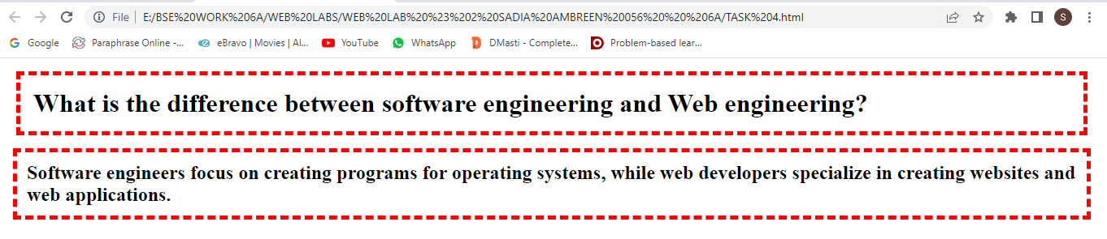

***TASK # 5***

*<!DOCTYPE html>*

*<html lang="en">*

*<head>*

*<meta charset="UTF-8">*

*<meta http-equiv="X-UA-Compatible" content="IE=edge">*

*<meta name="viewport" content="width=device-width, initial-scale=1.0">*

*<title>Document</title>*

*<style>*

*h1{*

*color: blue;*

*}*

*a{*

*color: blue;*

*}*

*a:hover{*

*color: rgb(229, 255, 0);*

*font-size: large;*

*}*

*a:active{*

*color: red;*

*text-decoration: none;*

*}*

*</style>*

*</head>*

*<body>*

*<h1>Here are my Favourite Sites:</h1>*

*<h2>Click a name to visit Site.</h2>*

*<ul>*

*<li><a href="https://www.facebook.com/">Facebook</a></li>*

*<li> <a href="https://twitter.com/i/flow/login?input_flow_data=%7B%22requested_variant%22%3A%22eyJsYW5nIjoiZW4ifQ%3D%3D%22%7D">Twitter</a></li>*

*<li><a href="https://foursquare.com/">Foursquare</a></li>*

*<li> <a href="https://www.google.com/">Google</a>*

*</li>*

*</ul>*

*</body>*

*</html>*

***OUTPUT:*** 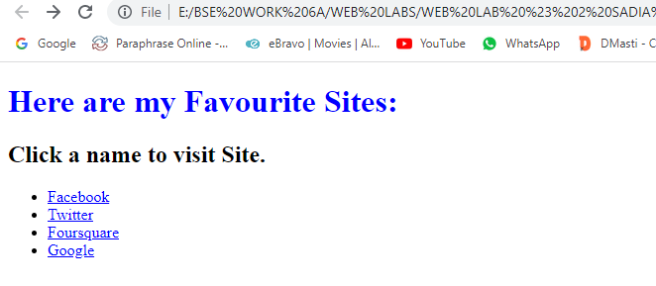

***TASK # 6:***

*<!DOCTYPE html>*

*<html lang="en">*

*<head>*

*<meta charset="UTF-8">*

*<meta http-equiv="X-UA-Compatible" content="IE=edge">*

*<meta name="viewport" content="width=device-width, initial-scale=1.0">*

*<title>Document</title>*

*<style>*

*.btn {*

*display: inline-block;*

*cursor: pointer;*

*padding: 30px 60px;*

*font-size: 50px;*

*border-radius: 19px;*

*background-color: rgb(36, 36, 36);*

*color: white;*

*border: 2px solid rgb(199, 10, 10);*

*}*

*.btn:hover {*

*background-color: rgb(78, 78, 78);*

*color: rgb(255, 38, 38);*

*border: 2px solid rgb(255, 196, 0);*

*}*

*.btn:active {*

*transform: scale(0.95);*

*}*

*</style>*

*</head>*

*<body>s*

*<div class="btn">Hover Me!</div>*

*</body>*

*</html>*

***OUTPUT:***



***\*\*\*\*\*\*\*\*\*\*\*\*\*\*\*\*\*\*\*\*\*\*\*\*\*\*\*\*\*\*\*\*\*\*\*\*\*\*\*\*\****

***THE END***

***\*\*\*\*\*\*\*\*\*\*\*\*\*\*\*\*\*\*\*\*\*\*\*\*\*\*\*\*\*\*\*\*\*\*\*\*\*\*\*\*\****